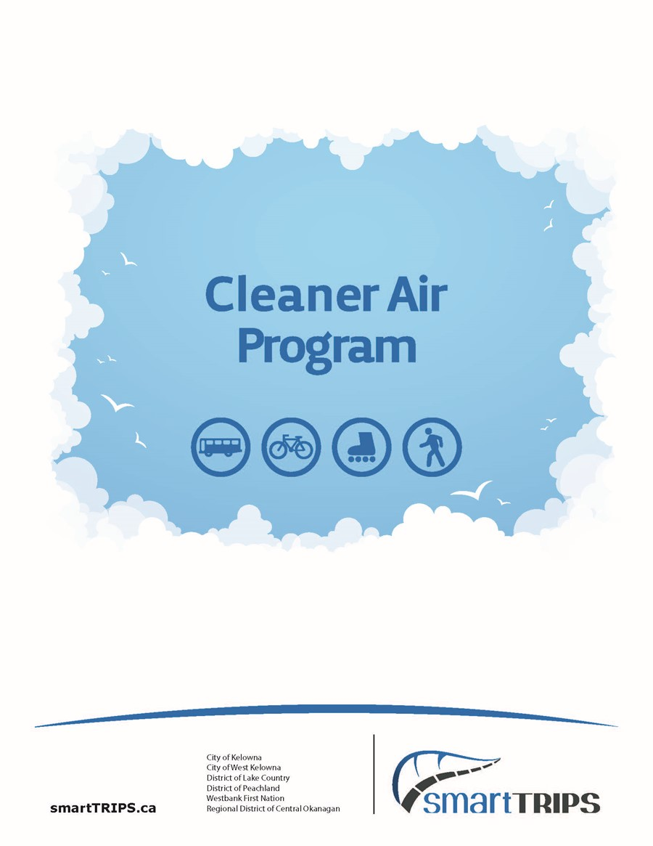

**Clean Air & Safe**

**Routes 4 Schools**

Cleaner Air Program for Elementary Schools in the Central Okanagan.













The Cleaner Air Program was prepared by Nancy Mora Castro, Regional Air Quality Coordinator.

Revised September 2023

**Contents**

Cleaner Air 4 Schools 4

Linking Cleaner Air 4 School with the British Colombia Curriculum 5

Cleaner Air 4 School Program suggested timeline 6

Air Pollution Lesson - Let’s Learn about Air Pollution 8

What is air pollution? 8

What makes the air dirty? 8

Air pollution today 8

How does air pollution affect you? 8

How do we know if the Air we breathe is clean? 9

What are the pollutants? 9

Where are the pollutants? 10

Everyone can help make our air cleaner! 11

Actions CHILDREN can take 11

Actions PARENTS & TEACHERS can take 11

Air Pollution Lesson Worksheet 12

Cleaner Air 4 Schools Activity # 1- Idling Survey 14

Idling- Background information 15

Cleaner Air 4 Schools Activity # 2- Surface Wipe 22

Cleaner Air 4 Schools Activity # 3- Idle Off 27

Cleaner Air 4 Schools Activity # 4- Idling Reduction Pledge 33

Cleaner Air 4 Schools Activity # 5- Clean Air Champion Badge and Certificate 35

Appendix 1- Learn about Air Pollution- Presentation 38

Appendix 2 – Air Pollution Facts 38

Appendix 3 – Fact Sheet- “Let’s Talk Air Pollution” 38

Appendix 4 - Fact Sheet- “Things you can do to Improve Air Quality” 38

# Cleaner Air 4 Schools

As part of the activities of the Clean Air & Safe Routes 4 Schools Program, the implementation of a program to raise awareness about air pollution is suggested and included in the School Action Plan. The Regional Air Quality Coordinator compiled information from various official sources like HASTE, Natural Resources Canada and the City of London, UK toolkit to design and tailor the program for Elementary Schools in Central Okanagan.

The Cleaner Air 4 School Program will be introduced to students and parents with the collaboration of teachers and the School Travel Plan Committee (the Parent Advisory Council or the Parent Support Group), through the following facilitated activities:

|  |  |
| --- | --- |
| Activity | Responsible for implementation |
| Learning about Air Pollution Lesson &  Classroom Activities | Teachers |
| Air Pollution Facts | Teachers &  PAC/PSG |

This document includes an **Air Pollution Lesson - “Learn about Air Pollution”** and five classroom activities suitable for students from grades 3 to 6. A PowerPoint presentation, included as a separate file - *Appendix 1*, was also designed to facilitate the “Learn about Air Pollution” lesson which includes the following information:

1. What is air pollution?
2. What makes the air dirty?
3. Air pollution today
4. How does air pollution affect you?
5. What are the pollutants?
6. Where are the pollutants?
7. Actions children can take.
8. Actions parents & teachers can take.

Five classroom activities are included to complement the Learn about Air Pollution lesson:

1. Idling Survey
2. Surface Wipe Activity
3. Idle Off
4. Idling Reduction Pledge
5. Clean Air Champion Badge and Certificate

The Air Pollution Facts included in a separate file- *Appendix 2*, contain 32 interesting facts related to idling, health, transportation emissions and actions to improve air quality. This material will cover the school year with constant reminders to be delivered, read, or discussed in class and to be included in the weekly newsletter by the PAC.

For more road safety tools and strategies please visit: [Road Safety Toolkit](https://www2.gov.bc.ca/assets/gov/driving-and-transportation/driving/consequences/vision-zero/resource-kit-community-road-safety-toolkit-module3.pdf)

## Linking Cleaner Air 4 School with the British Colombia Curriculum

The Cleaner Air 4 School Program activities can be of particular benefit to school children, because of their links to the social studies and science [curriculum](http://www.bced.gov.bc.ca/irp/gc.php?lang=en) in British Colombia:

|  |  |  |  |  |
| --- | --- | --- | --- | --- |
| Grade | Subject | Key Elements | Learning Outcomes | Indicator |
| 3 | Social Studies | Human and Physical Environment | Demonstrate a sense of responsibility for the local environment | -Identify a locally relevant environmental issue (pollution)  -Participate in activities to address a local environmental issue |
| 4 | Science | Life science: habitats and communities | Determine how personal choices and actions have environmental consequences | Document the steps involved in supporting actions that positively affect the school environment |
| 5 | Social Studies | Human and Physical Environment | Explain why sustainability is  Important | Speculate on the potential consequences of non‐sustainable practices in resource use |
| 6 | Social Studies | Economy and Technology | Evaluate the effects of technology on lifestyles and environments | Give examples of how their consumer choices may affect  people elsewhere in the world |

The Cleaner Air 4 school program will have the added benefit of continually reinforcing messages about air pollution and sustainable travel, encouraging more staff and parents to take up sustainable travel over time.

To cover 100% of the students over time, it’s suggested to deliver the Cleaner Air 4 School Program to grades 3, 4, 5 and 6 during the current school year and in the following years facilitate the program only to students in grade 3.

The suggested timeline illustrates how this program can be used within 1 to 6 weeks of learning and investigating air quality around the school.

If there are time constraints, teachers could deliver the “Air Pollution Lesson - Learn about Air Pollution” and only choose one or two classroom activities.

## Cleaner Air 4 School Program suggested timeline.

|  |  |  |  |  |  |  |  |  |  |
| --- | --- | --- | --- | --- | --- | --- | --- | --- | --- |
| Responsible | **Cleaner Air 4 School Program**  **Program Timeline** | **Oct-Nov or Apr-May** | | | | | | | **Next semester** |
|  | **Week** | 1 | 2 | 3 | 4 | 5 | 6 | 7 | 1-4 |
| Teachers | Air Pollution Lesson - Learn about Air Pollution | 1st week |  |  |  |  |  |  |  |
| Classroom Activities | Baseline Idling Survey | Surface Wipe Activity | Idle Off | Idling Reduction Pledge | Clean Air Champion  Badge | Follow-up Idling Survey |  | Follow-up Idling Survey |
| Send home – Fact Sheet “Let’s talk Air Pollution” Printed or/and through a newsletter |  | 2nd Week |  |  |  |  |  |  |
| Send home –Fact Sheet “Things you can do to improve air quality”  Printed or/and through a newsletter |  |  | 3rd  Week |  |  |  |  |  |
| Air Pollution Facts  (Read or discuss with the class- Every Monday (3-5 min) |  |  |  |  | Fact # 1 | Fact # 2 | Fact # 3… |  |
| Evaluation |  |  |  |  |  |  | Evaluate Results | Evaluate Results |
| Air Quality | Run an Idling Reduction Campaign  A school package is available upon request.  [Anti-Idling Material Request Form](https://forms.office.com/r/yi8mczr2SV).  The Air Quality program could provide a prize to the classroom with the most pledges signed. |  |  |  |  |  | 6th Week |  |  |
| Idling Survey |  |  |  |  |  |  | 7th  Week |  |
| PAC/PSG | Include “Air Pollution Facts” on the weekly newsletter or school website. (32 weeks) |  | Let’s talk about Air Pollution | Things you can do to improve air quality |  | Fact # 1 | Fact # 2 | Fact # 3… |  |
|  | Share idling survey findings and Follow up Classroom and Family Surveys |  |  |  |  |  |  | Through newsletter | Through newsletter |

The recommended procedure is:

1. Teachers deliver the Air Pollution lesson (ppt) and perform one or up to five suggested activities.
2. Share with the school community through the school newsletter, the provided fact Sheets- attached as *Appendix 3* *and 4*:

Appendix 3- “Let’s Talk Air Pollution”

Appendix 4- “Things you can do to improve Air Quality”

Then, the Air Pollution Facts (Appendix 2) could be delivered by the teachers weekly and be reinforced by the PAC through the weekly newsletter.

The Regional Air Quality Coordinator will provide and determine later with the School Committee's collaboration, the prize to the classroom with the most pledges signed, e.g., entry fee to the H2O, pizza party, etc.

In the following sections, teachers will find the resources and instructions to deliver the Cleaner Air 4 School Program. Through the Learn about Air Pollution lesson, there are links to videos to complement the lesson.

# 

# Air Pollution Lesson - Let’s Learn about Air Pollution

## What is air pollution?

Air pollution is anything that causes the air to become contaminated with pollutants at levels harmful to our health.

## What makes the air dirty?

* 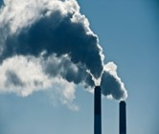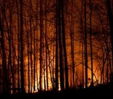Generally, air pollution comes from the burning of fossil fuels such as coal, oil, natural gas, gasoline, or diesel.
* This happens when we use energy supplies to do everyday activities, such as cooking, washing at home, or travelling by car.
* In 2007, open burning and residential wood burning were identified as the main causes of degraded air quality in Central Okanagan.
* However, recent Greenhouse Gases (GHG) emissions data highlights the increasing importance of vehicle emissions in contributing to air pollution.

## Air pollution today

* Today, when we think of air pollution, we should also think of **transport**, especially **cars**.
* Today there are about **140,000** vehicles registered in the Central Okanagan Region.
* The fuel they use – gasolineand diesel– causes bad gases to be ejected from the exhaust.
* These gases can be dangerous for **children**.

## 

## How does air pollution affect you?

* We encounter many kinds of air pollutants every day. They are being released in our neighbourhoods, our backyards, and inside our homes, and are finding their way into our lungs. Outdoor pollutants seep into houses, even through closed doors and windows.
* Air pollution is known to cause breathing problems, lung, and heart diseases, such as asthma. Children are particularly at risk, as their bodies are less resilient, and the pollutants have a more concentrated effect. [Be Air Aware!](https://www.youtube.com/watch?feature=player_embedded&v=kWesXfmH2go#t=0)

Air pollution can:

1. Affect your immune system, so that you can catch infections more easily.
2. Make you cough, sputter, wheeze, sneeze, or feel dizzy and it can make your eyes itch.

* Health Canada, in collaboration with colleagues at Environment and Climate Change Canada, updated estimates of health impacts of air pollution. Using the Air Quality Benefits Assessment Tool, they estimate that 1,600 premature deaths in B.C. in the calendar year 2015 can be linked to above-background air pollution (fine particulate matter, nitrogen dioxide and ozone) from all sources, with an economic valuation of $11.5B per year[1]
* Nationally, the health burden of air pollution was estimated at 14,600 premature deaths, 2.7 million asthma symptom days, and 35 million acute respiratory symptom days, with a total economic valuation equal to $114B per year.

## How do we know if the Air we breathe is clean?

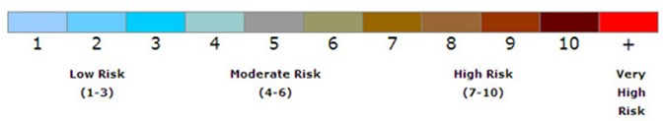The Air Quality Health Index or "AQHI" is a scale designed to help you understand what the air quality around you means to your health. The AQHI is measured on a scale ranging from 1-10+. The AQHI index values are grouped into health risk categories as shown below. These categories help you to easily and quickly identify your[***level of risk***](https://www.canada.ca/en/environment-climate-change/services/air-quality-health-index/health-risks.html). Check the [***Central Okanagan Air Pollution levels***](http://weather.gc.ca/airquality/pages/bcaq-008_e.html)!

One of the best ways to stay informed is to download the [**AQHI Canada app**](https://open.alberta.ca/blog/?page_id=160) and set up notifications for alerts when the AQHI in your community reaches the level at which you wish to be notified.

## What are the pollutants?

* The main pollutants in the Central Okanagan are Ozone (O3), Nitrogen Oxides (NOx) and Fine Particulate matter (PM2.5)

[**NOx**](https://www.canada.ca/en/environment-climate-change/services/air-pollution/pollutants/common-contaminants/nitrogen-oxides.html)(Nitrogen oxides) – NO2 (nitrogen dioxide) also contributes to acid rain, which damages trees and the stone on buildings. You can see the effect of NO2 on a hot summer day when it combines with other chemicals to make the sky look heavy and brownish grey. These pollutants combine with [Volatile Organic Compounds](https://www.canada.ca/en/environment-climate-change/services/air-pollution/pollutants/common-contaminants/volatile-organic-compounds.html) (VOCs) produce ground-level ozone.

[**Particulate matter**](https://www.canada.ca/en/environment-climate-change/services/air-pollution/pollutants/common-contaminants/particulate-matter.html)(PM) – These are tiny particles of dust and soot that are released into the air. When you breathe them in, they settle in the lower parts of your lungs. For example, [woodstoves release tiny particles](http://www.youtube.com/watch?feature=player_embedded&v=sJQ4IVDDA6Q) that can affect your health. But there are available [Burn it Smart Tools](https://www.rdco.com/en/environment/wood-heating.aspx#Wood-heating-best-practices) to avoid all the smoke!

[**Ozone (O3)**](https://www.canada.ca/en/environment-climate-change/services/air-pollution/pollutants/common-contaminants/ground-level-ozone.html) is a colourless, odourless gas made of three oxygen atoms. [Ozone](https://www.epa.gov/ozone-layer-protection) can form in two places:

1. **high up in the atmosphere 2) right down at the ground.**

When this gas is up high in the [ozone layer](http://mocomi.com/what-is-the-ozone-layer/) it’s “good” ozone and acts like sunscreen for the Earth – blocking out most of the Sun’s harmful ultraviolet rays. When it’s near the ground it’s “bad” ozone. This “Ground-level ozone” can affect our environment and our economy by damaging ecosystems and vegetation and accelerating global climate change.

**\*Students can see how individual choices, environmental factors, and different types of land use affect air pollution by using an** interactive air pollution simulator **to control the air quality in Smog City 2.** [Smog City 2: N/A: Free Download, Borrow, and Streaming: Internet Archive](https://archive.org/details/smog-city-2)

## Where are the pollutants?

* 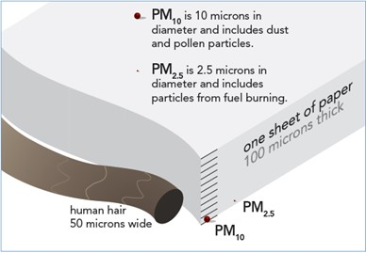Everywhere!
* Most pollutants are much too small to see without a microscope, but they still get into our lungs and affect our health.
* Sometimes specific areas could have higher concentrations of fine particulate due to:
  + Fuel combustion (use of vehicles)
  + Wood burning (from wood appliances and open burning)

Fine particulate is one of the pollutants of concern in the Okanagan. Fine particulate consists of particulates with diameters that are less or equal to 2.5 microns in size.

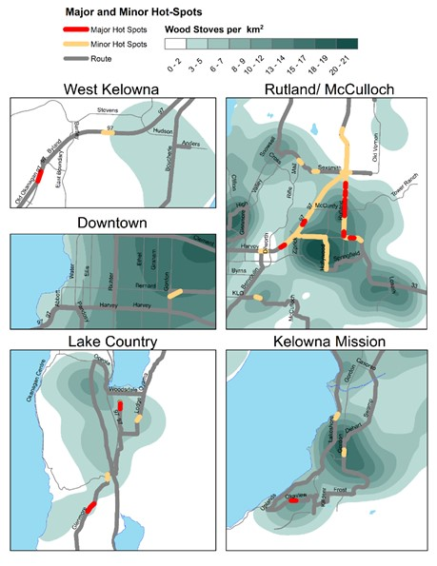We are susceptible to high PM2.5 concentrations due to the weather, poor air conditions during winter, topography, and local sources. A recent mobile study in Central Okanagan (2015-2016) showed that **certain neighbourhoods had a higher concentration of fine particulate (PM2.5) due to wood smoke and traffic**. This mobile monitoring study was performed through a specific route. The route was completed 26 times during November 2015-April 2016. The areas shown as major and minor hotspots had consistently higher concentration of PM2.5 during that sampling.

It is estimated that within the Central Okanagan are between 4,000-12,000 wood appliances in use- Source Ministry of the Environment.

The region is working on several policy changes to encourage the exchange of old wood-burning appliances (for more efficient ones) and is promoting better [wood-burning](https://www.rdco.com/en/environment/wood-heating.aspx#Wood-heating-best-practices) for residential and agricultural activities, among other strategies.

Farmers with large volumes of wood have access to a free chipping program, but more needs to be done in the near future to avoid open burning in the region.

If you use a wood appliance to heat your home, visit the RDCO webpage to find out about “[best wood burning practices”](https://www.rdco.com/en/environment/wood-heating.aspx#Wood-heating-best-practices):

* High-efficiency units allow you to burn a third less wood and get the same amount of heat.
* Advanced technology stoves mean less smoke, less work and big cost savings.
* The wood should be dry; moisture content of the wood should be under 20%, preferably around 15%. Moisture meters allow you to test the moisture level in wood, are available in stores and can cost as little as $20.

# Everyone can help make our air cleaner!

## Actions CHILDREN can take.

**Travel to school**

* ****Walk, cycle or scooter to school! It is good exercise and can reduce air pollution.
* Use public transport: take the bus instead of the car.
* If you must travel to school by car, try car-sharing with other friends.

**No idling**

* 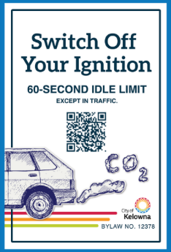If you must be picked up by car, tell your parents not to leave the engine on while they wait for you. This is called ‘idling’ and it is a big cause of air pollution around schools. Turning off the engine could reduce air pollution and save your parents some money.
* Turn off your car engine when you are stopped for longer than 60 seconds, except when in traffic.
* Idling for more than 10 seconds wastes more fuel and produces more carbon dioxide (CO2) than restarting your vehicle.
* City of Kelowna one-minute [Idling Control 12378](https://www.kelowna.ca/our-community/environment/air-quality) in effect since July 25, 2022*.*

**Spread the word!**

* Discuss air quality issues with your teachers, friends, and family.
* Make sure everyone you know is aware of the dangers of air pollution.

**Simple actions at home!**

* Energy-saving actions: such as switching on equipment only when needed, or setting the thermostat at the lowest comfortable temperature around 18°C to 21°C can reduce [CO2](https://www.epa.gov/ghgemissions/overview-greenhouse-gases) emitted which contributes to air pollution.
* Turn off the lights, TV, or computer when you are not using them.
* Wash your clothes in cold water and hang them out to dry instead of using a dryer when you can.
* Choose cleaner and more efficient heating devices. EPA-certified wood appliances and heat pumps are cleaner ways to heat a home.
* Recycle!

## Actions PARENTS & TEACHERS can take.

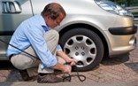**Promote sustainable travel**

* Encourage your children and their friends to walk and cycle.
* Encourage friends and family to walk and cycle or car-share.
* Try and reduce the amount your family uses the car, especially for journeys under 2 km.
* Discuss air quality issues with your school, friends, and family.

**If you must drive**

* Fully inflate car tires so your car uses less gasoline.
* Switch the engine off while waiting for your child after school.
* Ensure that you have your vehicle serviced at regular intervals.
* Don't start your engine until you're ready to travel. **If stopped for more than 60 seconds - except in traffic – turn the engine off**
* Avoid rapid acceleration and heavy braking: they both increase fuel consumption and air pollution.
* Stay within the speed limit: you use 30% more fuel to travel the same distance at 110 kilometres an hour than you do travelling at 80 kilometres an hour.

[what_can_individuals_do_combined-revised_2023.pdf (smarttrips.ca)](https://www.smarttrips.ca/sites/files/6/docs/pedometer/what_can_individuals_do_combined-revised_2023.pdf)

# Air Pollution Lesson Worksheet

1. Define Air Quality:

__________________________________________________________________________________

__________________________________________________________________________________

__________________________________________________________________________________

1. What can Affect Air Quality? List as many things as you can.

__________________________________________________________________________________

__________________________________________________________________________________

__________________________________________________________________________________

1. Which are the main Air Pollutants in our region?

__________________________________________________________________________________

__________________________________________________________________________________

1. How is ozone created?

__________________________________________________________________________________

__________________________________________________________________________________

5. List and discuss as a class the possible effects that air pollutants may have on the environment. How might air pollutants affect your health? List and discuss possible answers. You may need to use the internet to search for answers.

__________________________________________________________________________________

__________________________________________________________________________________

__________________________________________________________________________________

__________________________________________________________________________________

1. List at least 3 things that YOU can do to improve air quality in your school or community.

__________________________________________________________________________________

__________________________________________________________________________________

__________________________________________________________________________________

1. Fill out the Health Risk:

**Low High Moderate Very High**

|  |  |  |  |  |
| --- | --- | --- | --- | --- |
| Health Risk |  | Health Messages | | |
| **At-Risk Population\*** | **General Population** | |
|  |  |  |  | |
|  |  |  | |  |
| ___________ |  | **Avoid** strenuous activities outdoors. Children and the elderly should also avoid outdoor physical exertion. | | **Reduce** or reschedule strenuous activities outdoors, especially if you experience symptoms such as coughing and throat irritation. |
| ___________ |  | **Reduce** or reschedule strenuous activities outdoors. Children and the elderly should also take it easy. | | **Consider reducing** or rescheduling strenuous activities outdoors if you experience symptoms such as coughing and throat irritation |
| __________ |  | **Enjoy** your usual outdoor activities. | | **Ideal** air quality for outdoor activities. |
| ___________ |  | **Consider reducing** or rescheduling strenuous activities outdoors if you are experiencing symptoms. | | **No need to modify** your usual outdoor activities unless you experience symptoms such as coughing and throat irritation. |
|  |  |  | |  |

1. Investigate the current Air Quality Health Index (AQHI) Values for the Central Okanagan and check if there are any fires nearby and how the smoke will affect the region in the next 48hrs.

Steps:

* Go to the [Provincial Government website](http://www.bcairquality.ca/readings/index.html). Check [AQHI values](http://www.env.gov.bc.ca/epd/bcairquality/data/aqhi-table.html)
* Write the date and current AQHI values:
* Date ____________________________
* 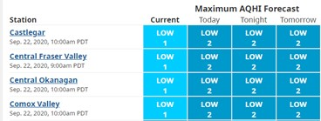Current AQHI _____________________
* Visit the [BlueSky Canada (Western Canada)](http://firesmoke.ca/forecasts/current/) smoke forecast page for up-to-date forecast information. Are there any fires nearby?

__________________________________________________

__________________________________________________

__________________________________________________

# Cleaner Air 4 Schools Activity # 1- Idling Survey

**Suitable for Grades:** 3-6

**Duration of Activity: 30 min**

**What is idling?**

When people leave their car engine running while they have stopped, this is called ‘idling’. A car is ‘idling’ if it has been left running for over **one minute** after stopping or parking. Idling can cause pollution around the school when parents pick up or drop off children. Their cars cough out dirty, smelly fumes!

**How do we monitor idling?**

To work out if idling is causing pollution around your school, you can count the number of **parents’ cars** outside your school that are idling. It’s best to count parents’ cars idling during the busy time in the morning before school starts and again in the afternoon when school ends.

For example, if your school starts at 8:30 and ends at 2:30, you could survey 8:30 - 9:00 am and 2:15- 2:45 pm, because parents may come earlier to drop off or wait for their children. Choose to do your idling survey on a day when most students leave school around the same time. Teachers should send students in groups, to a location beside the road near the school where parents drop off their children.

A baseline survey should be performed with the help of the participant grades; coordinate a 3-day survey, each day a different group or grade will oversee the survey. If two or more groups perform a survey during the same day, average the results for that day.

Set a goal for levels to reduce idling. We encourage the school to set an ambitious goal of reducing idling by at least 50%.

Follow-up surveys are needed; the suggested timeline is as follows:

|  |  |
| --- | --- |
| Action | Timeline |
| Baseline Idling Survey | First Week |
| 1st Follow-up Survey | One week after the last activity (Clean Air Champion Badge and Certificate) is delivered |
| 2nd Follow-up Survey | Six months later |

Compile, evaluate and discuss the idling survey with the group and send your results to the school committee for publication in the newsletter.

**Costs of activity:**

There are no costs associated with this activity.

## 

# Idling- Background information

**Why Do Canadians Idle?**

Warming up or cooling down a vehicle is the most common reason given for idling‚ in the winter and summer. Surveys show that Canadians also idle their vehicles for many other reasons that include:

* + waiting for passengers
  + stopping at railway crossings
  + waiting to park
  + running quick errands
  + sitting in drive-through lanes
  + waiting to refuel or to have the car washed
  + stopping to talk to an acquaintance or friend
  + preparing to leave the house

Calculations drawn from a Canadian survey of driving habits and behaviour suggest that in the peak of winter, ‚ many Canadian motorists idle their vehicles for about eight minutes a day‚ resulting in a combined total of more than 75 million minutes of idling a day. This day alone uses over 2.2 million litres of fuel and produces over five million kilograms of greenhouse gases (GHGs) which is equal to the amount of fuel required to drive over 1100 vehicles for a year or to idle one vehicle for 144 years!

1. **What’s the problem with idling?**

* Pollutants – A variety of pollutants given off from vehicle emissions that impact our health and the environment. Of particular concern are particulate matter (PM) and CO2
* Pollutants impacts our air quality which impacts all living things
* For humans, vehicle emissions impact our health, especially those with respiratory problems. Particulate matter (PM) is breathed deep into the lungs.
* Impacts on Climate change
* Scientists believe that global warming is being caused by increasing concentrations of greenhouse gases (GHG) in the atmosphere. As more gases accumulate, they trap heat near the earth’s surface, which causes temperatures to rise. Human activities, such as burning fossil fuels, are a major source of GHG. Transportation is the single largest source of GHG in Canada. CO2 emissions from our vehicles are unavoidable (at least until zero-emission vehicles are on the market); emissions from idling vehicles are completely unnecessary and can easily be prevented – with the turn of a key.
* In Canada, if we all reduced our idling by just “five” minutes every day, we could prevent more than two million tonnes of CO2 from entering the atmosphere each year! That’s the equivalent of taking 350,000 cars off the road.
* Impacts on the wallet - Waste of gas and money
* Believe it or not, if you idle your vehicle for more than 10 seconds, you use more fuel than it would take to restart your engine.

**If stopped for more than 60 seconds - except in traffic – turn the engine off. Unnecessary idling wastes money and fuel and produces greenhouse gases (GHGs) that contribute to climate change. (NRCan)**

1. **Some solutions to idling include:**
   * Reduce your time idling – park and walk, don’t arrive at school early for pick-up, don’t go through drive-throughs, etc.
   * Turn vehicles off (go inside and wait)

* With today's computer-controlled engines, even on cold winter days usually no more than two to three minutes of idling is enough warm-up time needed for the average vehicle before starting to drive – but make sure that windows are free from snow and properly defrosted before driving away.
* Cars warm faster and operate more efficiently when being driven. Warming up the vehicle means more than warming the engine. The tires, transmission, wheel bearings and other moving parts also need to be warmed up for the vehicle to perform well. Most of these parts don't begin to warm up until you drive the vehicle.
* Vehicle engine emissions create ground level ozone. Ozone is a respiratory irritant. Walk or bike whenever you can to reduce vehicle use.
* If every driver of a light-duty vehicle avoided idling by three minutes a day, collectively over the year, we would save 630 million litres of fuel, over 1.4 million tonnes of GHG emissions, and $630 million annually in fuel costs (assuming fuel costs are $1.00/L).
* You can help reduce the impact of cold stars – and reduce idling times – by using a block heater on cold winter days. This device warms the coolant, which in turn warms the engine block and lubricants. The engine will start more easily and reach its proper operating temperature faster.
* You do not need to leave a block heater plugged in overnight to warm the engine – two hours is more than enough. You can use an automatic timer to switch on the block heater two hours before you leave. At -20°C, block heaters can improve overall fuel economy by as much as 10 percent. For a single short trip at -25°C your fuel savings could be in the order of 25 percent.
* City of Kelowna one-minute [Idling Control 12378](https://www.kelowna.ca/our-community/environment/air-quality) in effect since July 25, 2022*.*

**Idling Survey Instructions**

Fill out the form on the next page with your name, the date, and your location. You will be counting cars in two 15-minute blocks of time. Follow the steps below so we can compare everyone’s results later.

1. In a group of three, choose who you will be.

Champion 1 **Observer**: spot and identify parents’ cars.

Champion 2 **Timer**: time how long parents’ cars are left idling.

Champion 3 **Recorder**: record the number of cars idling and not idling.

1. What is the time? Write the time in ‘Start Time’ (e.g., 8:30 am).
2. What time should you stop counting cars? The **Timer** should make sure that you stop counting cars after 15 minutes.
3. The **Observer** looks for parents’ cars that are idling and not idling and tells the **Timer**.
4. The **Timer** uses a stopwatch to time if cars have been idling for at least **one minute**.
5. The **Recorder** puts one dash in the column ‘Number of cars idling’ every time the **Observer** and the **Timer** find an idling car, and one dash in the column ‘Number of cars not idling’ every time the **Observer** spots a parked car that is not idling
6. At the end of 15 minutes, the **Timer** tells the **Observer** to stop counting and the **Recorder** writes the finish time in the column ‘End Time’ (e.g., 8:45 am). Add up the number of cars idling and not idling and record this in the ‘total’ column.
7. After a 1-minute break, you can swap jobs. Repeat steps 1-6 and record your findings in the second row.
8. When you finish counting cars for the second time, add up all the cars idling and put this number in the ‘total’ column on the bottom row. Add up all the cars not idling and put this number in the ‘total’ column on the bottom row.
9. Repeat steps 1-8 in the afternoon.
10. At the end of the day, give your record form to your teacher. Do you think idling is a problem at your school? If yes, what can you do about it? Discuss.

**How to identify an idling vehicle:**

|  |  |
| --- | --- |
| **1. Look** for exhaust fumes | **4. Smell** of exhaust fumes |
| **2. Listen** for the engine | **5. Look** for headlights being on |
|  |  |

After the class completes the survey of how many vehicles are idling their engines and for how long. Use the following information to create statistics around how much energy is wasted, how much money is wasted, and how much carbon dioxide is produced from vehicles idling around the school.

* Every 10 minutes of idling uses at least 0.1 litres of gasoline.
* Gas costs, on average, $0.80 per litre.
* For every litre of gasoline consumed, the average car produces 2.4 kilograms of Carbon Dioxide

**Baseline Idling Observation Form - _____________ School** Group ___________________________

Observer: _________________Timer _________________Recorder _________________ Date of observation_________________

Location/Street ___________________________________Weather Conditions (25C, sunny): _______________________________

**Morning**

|  |  |  |  |  |  |  |
| --- | --- | --- | --- | --- | --- | --- |
| **Idling Observation Form** | | | | | | |
| **Session** | **Start time** | **End time** | **Number of cars idling** | **Total** | **Number of cars NOT idling** | **Total** |
| **Session 1**  **(15 min)** |  |  |  |  |  |  |
| **Session 2**  **(15 min)** |  |  |  |  |  |  |
| **Total number of** | | | **Cars idling** |  | **Cars NOT idling** |  |

**Afternoon**

|  |  |  |  |  |  |  |
| --- | --- | --- | --- | --- | --- | --- |
| **Idling Observation Form** | | | | | | |
| **Session** | **Start time** | **End time** | **Number of cars idling** | **Total** | **Number of cars NOT idling** | **Total** |
| **Session 1**  **(15 min)** |  |  |  |  |  |  |
| **Session 2**  **(15 min)** |  |  |  |  |  |  |
| **Total number of** | | | **Cars idling** |  | **Cars NOT idling** |  |

**Follow-up Idling Observation Form - _____________ School** Group ___________________________

Observer: _________________Timer _________________Recorder _________________ Date of observation_________________

Location/Street ___________________________________Weather Conditions (25C, sunny): _______________________________

**Morning**

|  |  |  |  |  |  |  |
| --- | --- | --- | --- | --- | --- | --- |
| **Idling Observation Form** | | | | | | |
| **Session** | **Start time** | **End time** | **Number of cars idling** | **Total** | **Number of cars NOT idling** | **Total** |
| **Session 1**  **(15 min)** |  |  |  |  |  |  |
| **Session 2**  **(15 min)** |  |  |  |  |  |  |
| **Total number of** | | | **Cars idling** |  | **Cars NOT idling** |  |

**Afternoon**

|  |  |  |  |  |  |  |
| --- | --- | --- | --- | --- | --- | --- |
| **Idling Observation Form** | | | | | | |
| **Session** | **Start time** | **End time** | **Number of cars idling** | **Total** | **Number of cars NOT idling** | **Total** |
| **Session 1**  **(15 min)** |  |  |  |  |  |  |
| **Session 2**  **(15 min)** |  |  |  |  |  |  |
| **Total number of** | | | **Cars idling** |  | **Cars NOT idling** |  |

**Results of Baseline Idling Survey - _____________________ School**

Group: _____________________Teacher_____________________________ Date of Survey (Day 1) _____________________

Weather Conditions (25C, sunny): ____________________________________

1a. The total number of Cars Idling around our school: _______________________ (sum morning + afternoon session)

Group: _____________________Teacher_____________________________ Date of Survey (Day 2) _____________________

Weather Conditions (25C, sunny): ____________________________________

2a. The total number of Cars Idling around our school: _______________________ (sum morning + afternoon session)

Group: _____________________Teacher_____________________________ Date of Survey (Day 3) _____________________

Weather Conditions (25C, sunny): ____________________________________

3a. The total number of Cars Idling around our school: _______________________ (sum morning + afternoon session)

*******************************************************************************************************************************************************

**Baseline-Total of cars idling around the school during the 3 days’ survey** = _______________________

Sum (1a + 2a +3a)

**The school set an ambitious goal of reducing idling by**  ________%

**Results of Follow-up Idling Survey - __________________ School**

Group: _____________________Teacher_____________________________ Date of Survey (Day 1) _____________________

Weather Conditions (25C, sunny): ____________________________________

1a. The total number of Cars Idling around our school: _______________________ (sum morning + afternoon session)

Group: _____________________Teacher_____________________________ Date of Survey (Day 2) _____________________

Weather Conditions (25C, sunny): ____________________________________

2a. The total number of Cars Idling around our school: _______________________ (sum morning + afternoon session)

Group: _____________________Teacher_____________________________ Date of Survey (Day 3) _____________________

Weather Conditions (25C, sunny): ____________________________________

3a. The total number of Cars Idling around our school: _______________________ (sum morning + afternoon session)

*******************************************************************************************************************************************************

**Follow-up- Total of cars idling around the school during the 3 days’ survey** = _______________________

Sum (1a + 2a +3a)

**The school goal of reducing idling was**  _____%

**After completion of the 6 weeks Air Program, we achieved an idling reduction of** __________%

**After six months of the Clean Air Program, we achieved an idling reduction of** __________%

# 

# Cleaner Air 4 Schools Activity # 2- Surface Wipe

**Suitable for Grades:** 3-6

**Duration of Activity:** 1 hour

**What is it?**

Surface wipe analysis is a cost-effective and easy way to identify levels of particulate matter, specifically in relation to their concentrations at different heights and locations.

**How to use it:**

Surface wipe analysis uses a piece of sticky tape or moist cotton ball to sample the particulate matter that is deposited on surfaces. You can use this technique to sample the deposition of particulate matter on surfaces in different locations, or at different heights. You can sample a range of surfaces using this technique including, leaves on trees, poles, walls, or doors around the school. Your sample provides an immediate visual indication of levels of pollution. It is also useful to explore how levels of pollution may vary depending on height and distance from roads. Greater concentrations of particulate matter at lower height levels pose a greater risk to children.

**Costs of activity:**

Costs for this activity are minimal, requiring only cotton balls or sticky tape, to wipe surfaces and examine them.

**Surface Wipe Activity Instructions**

**What is it?** Surface wipe analysis is a straightforward way to measure how much particulate matter there is at various locations and different heights.

**How to use it**

Surface wipe analysis uses a piece of sticky tape or a moist cotton ball to sample the particulate matter on surfaces. You can sample various surfaces using surface wipe analysis including leaves on trees, poles, walls, or doors around the school. Your sample will show you how much pollution there is straight away. It is also useful to explore how levels of pollution may be different at different heights and different distances from roads. If there is a lot of pollution at low heights this could be dangerous to children.

**What do you need?**

1. 2cm wide clear sticky tape or cotton balls
2. A tape measure at least 120 cm long

**Sampling steps:**

1. Find the surfaces you want to measure (tip: avoid wet surfaces). We suggest three different surfaces:
   * **a door inside the school**
   * **a pole of street/traffic sign**
   * **a wall outside school**

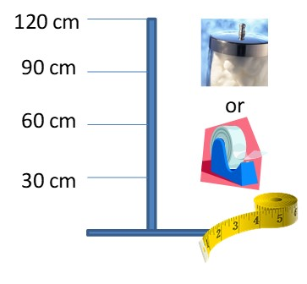

1. Use the tape measure to identify 4 spots at different heights: 120cm, 90cm, 60cm and 30cm.
2. For sticky tape - cut the clear tape into 10cm strips. Press the sticky side of the tape firmly onto the surface, leave for 10 seconds and then remove it. For cotton balls – dampen a cotton ball in a little water and wipe over a small area (about 10cm by 2cm)
3. Dirt and pollutants from the surface will have stuck to the tape or ball. Paste the tape or ball on the record sheet.
4. Repeat the steps above, and then compare the levels of pollution at different heights from the same surface.
5. Mark the pollution level from 1 to 4: 1 for the dirtiest sample and 4 for the cleanest sample. Could you tell if lower or higher heights are more polluted?

7. Repeat steps 1 to 6 for two other surfaces. Can you tell which surface is more polluted?

### 

**Surface Wipe Record Form (1/3)**

**School:** __________________**Date:** _____________________**Weather:** _______________________

**Participants:** _______________________________________________________________________

Paste your tape or cotton ball samples below. Can you see the differences between them? Try to compare the samples and mark their levels of pollution: 1 for the dirtiest sample, 4 for the cleanest sample.

|  |  |  |  |
| --- | --- | --- | --- |
| **Location 1: Door inside the school** | | | |
| **Surface Details** | **Height**  **cm** | **Paste your tape or cotton ball samples here!** | **Level**  **1 to 4** |
| **C:\Users\nmcastro\AppData\Local\Microsoft\Windows\Temporary Internet Files\Content.IE5\PRGYCHZ1\MC900330154[1].wmf** | **120** |  |  |
| **90** |  |  |
| **60** |  |  |
| **30** |  |  |

**Surface Wipe Record Form (2/3)**

|  |  |  |  |
| --- | --- | --- | --- |
| **Location 2: Pole of street/ traffic sign** | | | |
| **Surface Details** | **Height**  **cm** | **Paste your tape or cotton ball samples here!** | **Level**  **1 to 4** |
|  | **120** |  |  |
| **90** |  |  |
| **60** |  |  |
| **30** |  |  |

**Surface Wipe Record Form (3/3)**

|  |  |  |  |
| --- | --- | --- | --- |
| **Location 3: Wall outside the school** | | | |
| **Surface Details** | **Height**  **cm** | **Paste your tape or cotton ball samples here!** | **Level**  **1 to 4** |
|  | **120** |  |  |
| **90** |  |  |
| **60** |  |  |
| **30** |  |  |

# Cleaner Air 4 Schools Activity # 3- Idle Off

**Suitable for Grades:** 3-6

**Duration of Activity: 30 min**

**Objective**

Students will sort out myths from the truth on the topic of engine idling and transportation and compare and create guidelines for when to turn engine motors off.

**Materials**

* + Myth cards
  + Instruction card
  + True and false cards

**Preparation**

Print, mount, and laminate (optional) myth, instruction, and true/false cards.

**Procedure:**

1. Choose one person in the group to be the reader, they will be reading the myth cards aloud.
2. Explain that it will be up to each person in the group to decide if the myth is true or false. If they believe it to be true, they stand next to the true card; if they believe the myth to be false, they should stand next to the false card. Have each participant keep track of their correct answers to see how well they did.
3. The reader should then read out one myth card at a time.
4. Finally, try to produce guidelines or slogans to encourage people to turn their engines off.

**Costs of activity:**

The cost associated with this activity is minimal.

TRUE

- - - - - - - - - - - - - - - - - - - - - - - - - - - - - - -- - - - -- -- -- - - - - - - - - - - - - - - - - - - - - - - - - - -



FALSE

|  |  |  |
| --- | --- | --- |
|  | | |
| There are over 34.3 million cars in  Canada  True! (Data 2017) | | Highways, roads, and parking lots cover nearly 50% of the surface area of most North American Cities.  True! |
| **Idle Off**  **Idle Off** | | |
|  | | |
| I need to warm up my car by idling it before driving.  False - your car warms up better and faster by driving than idling, even in extremely freezing weather 30 seconds is enough to get your car ready. | | Transportation is the largest  contributor to Canada’s greenhouse  gas emissions.  True - the personal use of cars,  sport-utility vehicles and light trucks  accounts for 55 percent of Canada’s transportation emissions. |
| **Idle Off**  **Idle Of** | | |
|  | | |
| It does not save much fuel to turn the  car off when stopped.  False! - If every driver vehicle in Canada stopped idling for just 5 minutes a day, we would save 1.6 million litres of fuel worth more than $1.2 million. | Globally, there is a new car on the  road every second.  True! | |
| **Idle Off**  **Idle Of** | | |
|  | | |
| Idling only happens for a few  minutes.  False! - A recent study showed that  on an average summer day, the time  spent idling by Canadians adds up to  more than 46 million minutes. | | Idling the car does not affect the  engine.  False - idling causes fuel residues to build up that can contaminate engine oil and damage engine parts. |
| **Idle Off**  **Idle Of** | | |
|  | | |
| One public bus can replace 40 cars  on the road.  True! | | Walking, biking, using public  transportation and carpooling are  all good ways to reduce vehicle  emissions in your area.  True! |
| **Idle Off**  **Idle Of** | | |
|  | | |
| In the Central Okanagan 61% of air  Pollution comes from vehicles.  True! | | For every litre of gasoline used, the  the average car produces 2.4 kilograms  of Carbon Dioxide, a greenhouse  gas.  True! |
| **IIdle Off**  **Idle Of** | | |
|  | | |
|  | |  |
|  | | |
|  | | |
| Idling and vehicle emissions only  affect the environment.  False - airborne pollutants from  vehicles worsen asthma, impair lung  function and can even cause death. | | Canadian cities do not have problems  with air quality.  False - in a recent report, all  examined Canadian cities had  average annual ozone levels above  the acceptable limit. |
| **Idle Off**  **Idle Of** | | |
|  | | |
| Idling only affects the environment  through greenhouse gases.  False - idling contributes to acid rain  (Nitrogen oxides), smog (hydrocarbons  and ground-level ozone), and the  greenhouse effect, as well as releasing  hazardous chemicals like benzene. | | The average car is driven 15,000  kilometres per year in Canada.  True! |
| **Idle Off**  **Idle Of** | | |
|  | | |

# Cleaner Air 4 Schools Activity # 4- Idling Reduction Art and Pledge

**Suitable for Grades:** 3-6

**Objective**

****Students may create a drawing related to air pollution, show the art piece to their parents, and ask them to sign the Idling Reduction Pledge online.

**Materials**

* + Idling Reduction Pledge Form

**Preparation**

Print the Idling Reduction Pledge Form and provide one copy to each student in the classroom.

**Procedure:**

The students will prepare a drawing related to air pollution and idling, take the form home and discuss with their parents how idling can affect our local air and health will ask their parents for their commitment to reducing Idling every time they use a car.

Here are some important reminders:

* Idling can cause pollution around the school when our parents pick up or drop off children.
* If you are going to be stopped for more than 60 seconds – except in traffic – you should turn the engine off.
* Unnecessary idling wastes money and fuel and produces greenhouse gases that contribute to climate change.
* We have the power to reduce air pollution around our school and in our community by turning off the engine, walking, and biking more often to and from school!

To encourage students’ participation, the classroom that collects more Idling Reduction Pledges could receive a prize (TBD) which will be provided by the Air Quality program.

Display the pledges and colourful drawings throughout the school! You can also take some samples of the best drawings to be posted in the school newsletter.

Join the province-wide movement and act against climate change and improve air quality; parents, teachers and children can pledge to take individual actions like stop idling.

As a country, there is still much to do! Check the [Climate Action Tracker](https://climateactiontracker.org/countries/canada/).

|  |
| --- |
| **Idling Reduction Art and Pledge** |

Student’s name ______________________

I used the online fuel and money estimator and learned that I can save _______($/year)

### Reduce Emissions- Switch off your Ignition.

* More than 10 seconds of idling uses more fuel than restarting the engine.
* The recommended warm-up time for cars, vans, light trucks, and sport utility vehicles is no longer than 30 seconds, even in winter!

Together, we can limit local air pollution and the effects of climate change from human activities that we can control.

# Cleaner Air 4 Schools Activity # 5- Clean Air Champion Badge and Certificate

**Suitable for Grades:** 3-6

**Objective**

Students will receive an official Clean Air Champion Badge and Certificate.

**Materials**

* + Clean Air Champion Badge and Certificate

**Preparation**

Print the Clean Air Champion badge and provide one copy to each student in the classroom (if possible, on thick paper). They should colour and put their names on it. Print the certificates (if possible, in colour). You can also request the colour-printed certificates to airquality@kelowna.ca

**Procedure:**

The students will receive the badge after they complete the Learn about Air Pollution lesson and perform the four activities above. The certificates should be signed and delivered by the teacher once the group brings back the idling reduction forms signed by their parents.

When the teacher delivers the classroom certificates all kids should pledge:

"I pledge to do all I can to help protect the air."

|  |
| --- |
| **Clean Air Champion Badge Clean Air Champion Badge** |

|  |  |
| --- | --- |
| Cut out your official Clean Air  Champion badge! Print your  name in the "OFFICER" box! | Cut out your official Clean Air  Champion badge! Print your  name in the "OFFICER" box! |

|  |
| --- |
| **Clean Air Champion Badge Clean Air Champion Badge** |

|  |  |
| --- | --- |
| Cut out your official Clean Air  Champion badge! Print your  name in the "OFFICER" box! | Cut out your official Clean Air  Champion badge! Print your  name in the "OFFICER" box! |

**THE CLEAN AIR CHAMPION Certificate is on the next page.**

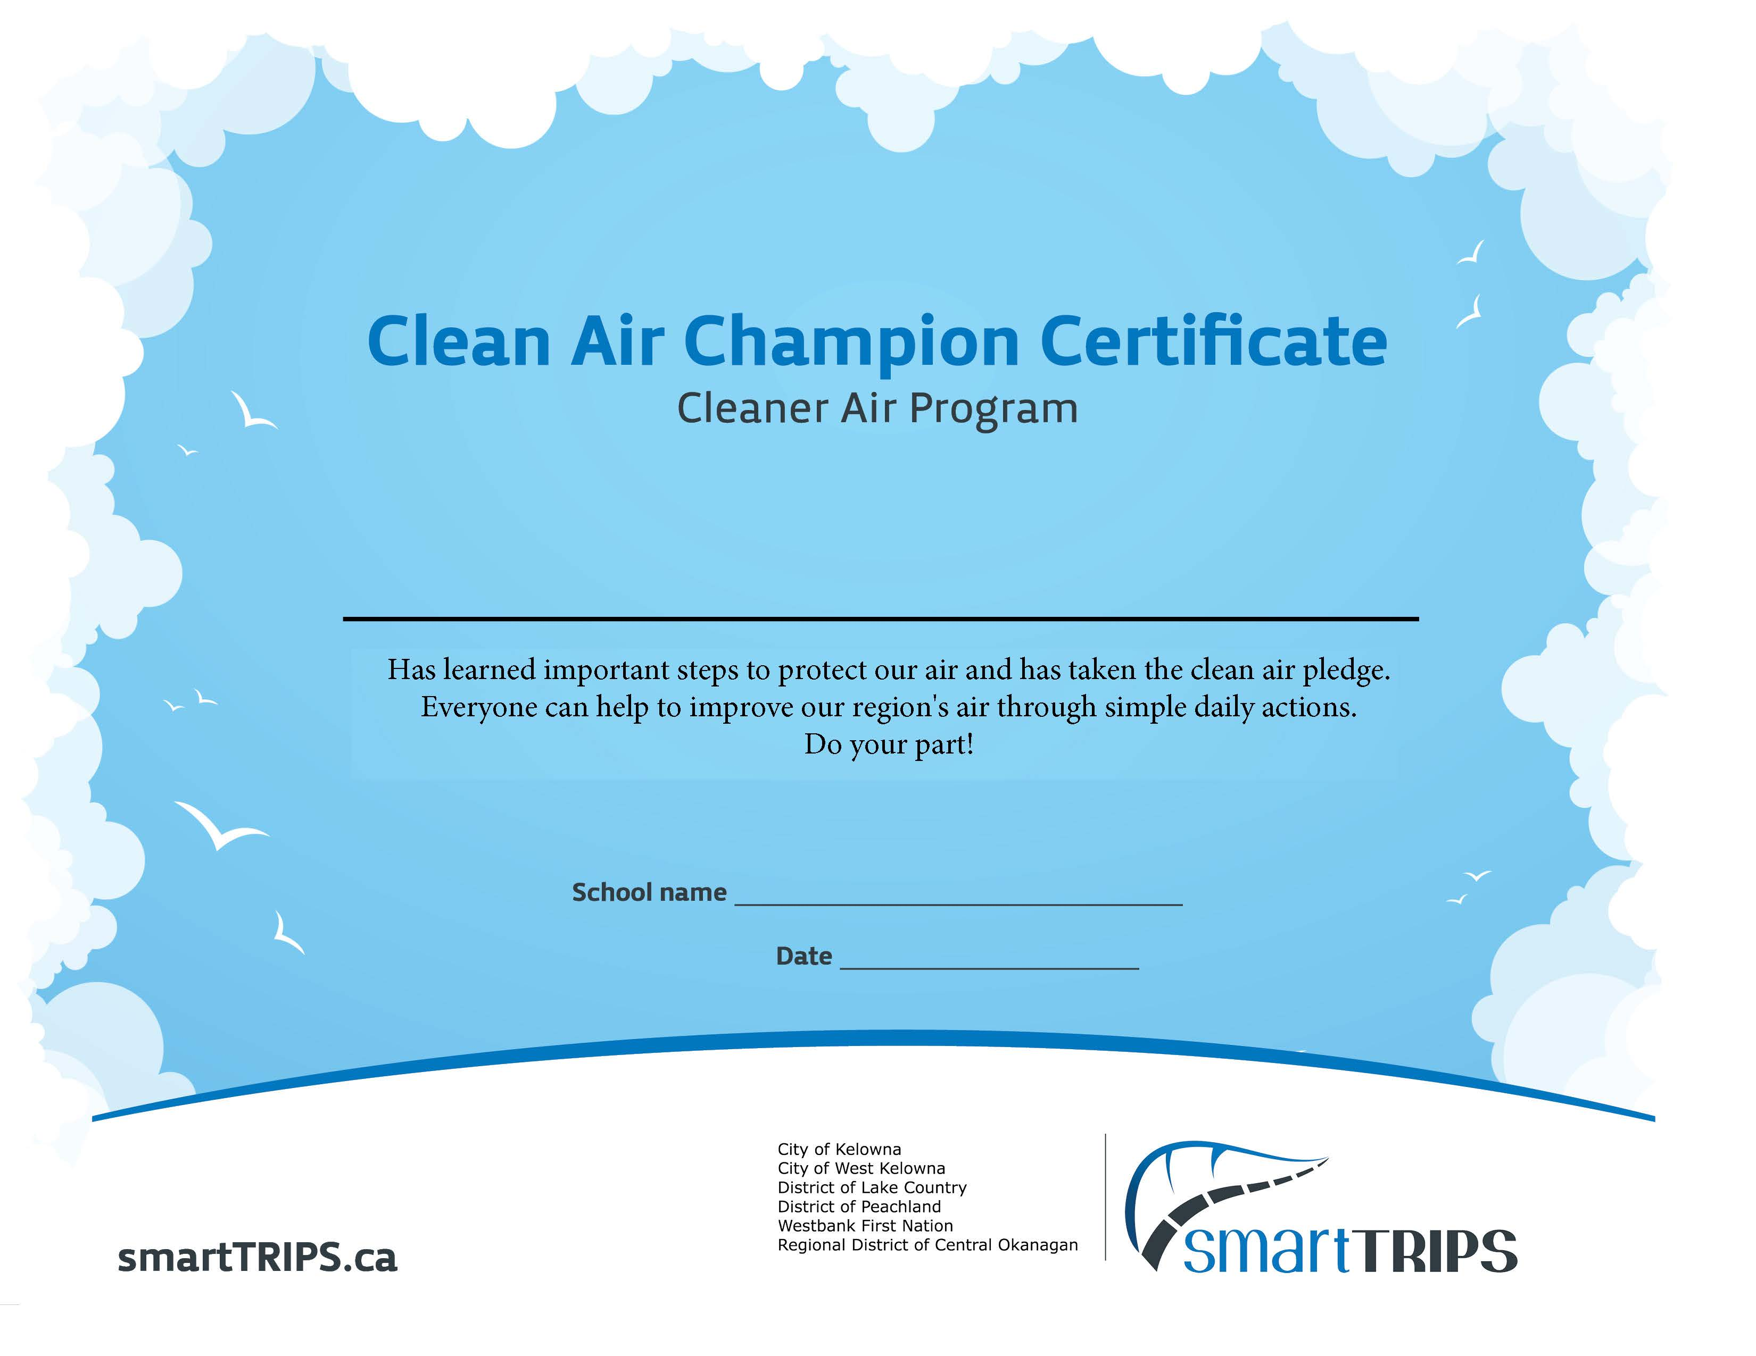

Attached as separate documents:

# Appendix 1- Learn about Air Pollution- Presentation

PowerPoint Presentation

# Appendix 2 – Air Pollution Facts

Word document

# Appendix 3 – Fact Sheet- “Let’s Talk Air Pollution”

PDF file

# Appendix 4 - Fact Sheet- “Things you can do to Improve Air Quality”

PDF file

**Acknowledgements:**

Thanks to the following organizations for Information on Safe Routes to schools:

Pacific Resource Conservation Society & Destination Conservation Air Quality- Sacramento Region, USA



**Cleaner Air Program for Elementary Schools in the Central Okanagan**

**2023**

Questions or concerns should be directed to:

Regional Air Quality Program

[rdco.com/airquality](http://www.rdco.com/airquality)

[airquality@kelowna.ca](mailto:airquality@kelowna.ca)

ph. 250-469-8408

This publication is intended for guidance only and may be impacted by changes in legislation, bylaws, policies, and procedures adopted after the date of publication. The use of this publication does not constitute the rendering of legal advice.

1. [State of the Air 2020](https://bc.lung.ca/sites/default/files/1104-State%20Of%20The%20Air%202020_R5_Sept13_web.pdf)