CLEANER AIR 4 Elementary Schools in The Central Okanagan

APPENDIX 2

Air Pollution Facts

This document contains 32 interesting Air Pollution Facts related to idling, health, transportation emissions and actions to improve air quality; this material will cover the school year of constant reminders to be delivered, read, or discussed in class and to be included on the weekly newsletter by the school committee.

The Air Pollution Facts are distributed as follows:
  - 11- Idling
  - 4 - Health
  - 3 – Transportation Emissions
  - 14 – Improve Air Quality

The suggested Cleaner Air 4 School timeline is as follows:

Responsible | Cleaner Air 4 School Program  Program Timeline | Oct-Nov or Apr-May |  |  |  |  |  |  | Next semester
 | Week | 1 | 2 | 3 | 4 | 5 | 6 | 7 | 1-4
Teachers | Air Pollution Lesson - Learn about Air Pollution | 1st week
 | Classroom Activities | Baseline Idling Survey | Surface Wipe Activity | Idle Off | Idling Reduction Pledge | Clean Air Champion  Badge | Follow-up Idling Survey |  | Follow-up Idling Survey
 | Send home – Fact Sheet “Let’s talk Air Pollution” Printed or/and through the newsletter |  | 2nd Week
 | Send home –Fact Sheet “Things you can do to improve air quality”  Printed or/and through the newsletter |  |  | 3rd  Week
 | Air Pollution Facts  (Read or discuss with the class- Every Monday (3-5 min) |  |  |  |  | Fact # 1 | Fact # 2 | Fact # 3…
 | Evaluation |  |  |  |  |  |  | Evaluate Results | Evaluate Results
Air Quality | Run an Idling Reduction Campaign  A school package is available upon request.  Anti-Idling Material Request Form.  The Air Quality program could provide a prize to the classroom with the most pledges signed. |  |  |  |  |  | 6th Week
 | Idling Survey |  |  |  |  |  |  | 7th  Week
PAC/PSG | Include “Air Pollution Facts” on the weekly newsletter or school website. (32 weeks) |  | Let’s talk about Air Pollution | Things you can do to improve air quality |  | Fact # 1 | Fact # 2 | Fact # 3…
 | Share idling survey findings and Follow up Classroom and Family Surveys |  |  |  |  |  |  | Through newsletter | Through newsletter

Instructions to teachers

- The Air Pollution facts should be read and discussed after the Air pollution lesson and the proposed activities have been facilitated.
- Set one day a week to read the Facts and discuss them with the class this could take just 3-5 min a week!
- Monday is highly recommended to increase awareness about air pollution, and transportation choices
- Encourage students to walk, cycle or skate during the week to go to and from school or while doing extra activities near their homes.
- Print the facts and select a different reader each week to involve the students in the process.
- The answers to the questions/guesses are upside down
- Check mark ☑ the fact that has been read, so you can easily keep track!

Instructions to the school committee

To add the Air Pollution Fact to the weekly newsletter:
- Select and Copy the Fact of the week (ctrl C)
- If necessary- Paste as “Paste special” “Picture (Enhance Metafile) for better quality.

Sending the facts through the newsletter is an essential piece to raise awareness about air pollution and to encourage more staff and parents to take up sustainable travel over time.

Sources
http://www.hastebc.org/info/facts-about-transportation-emissions (no longer available).
http://oee.nrcan.gc.ca/transportation/idling/facts.cfm?attr=8

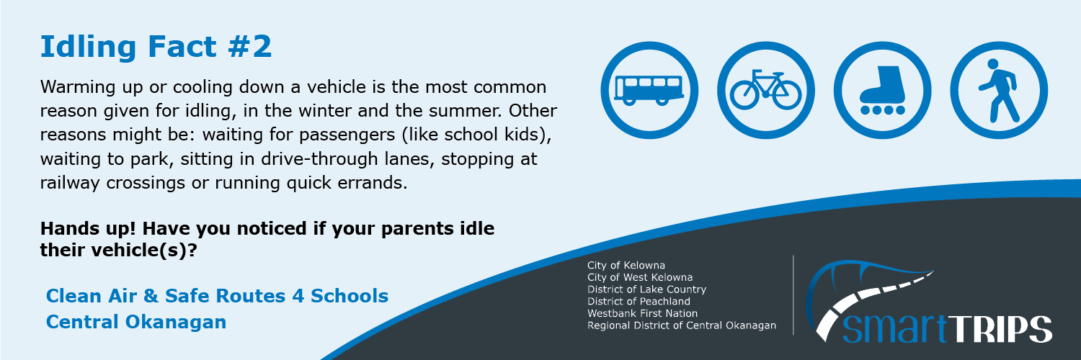
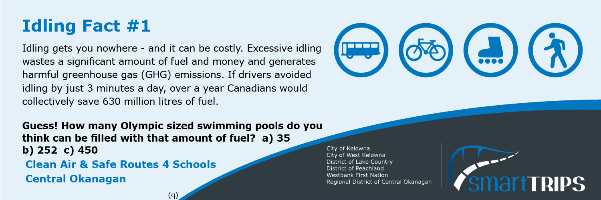
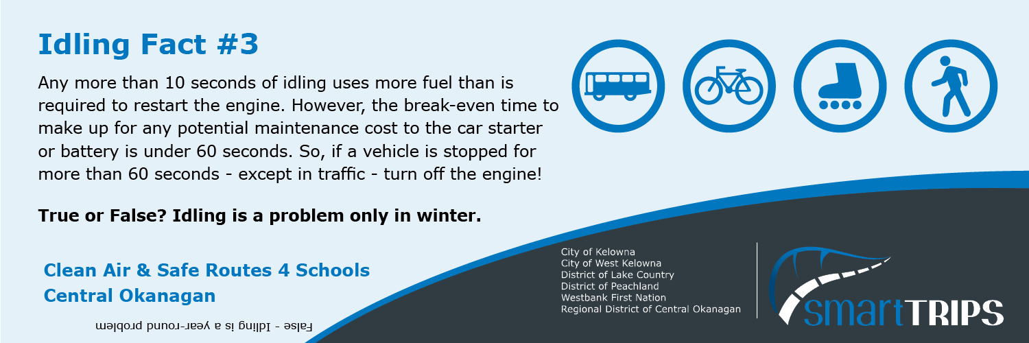

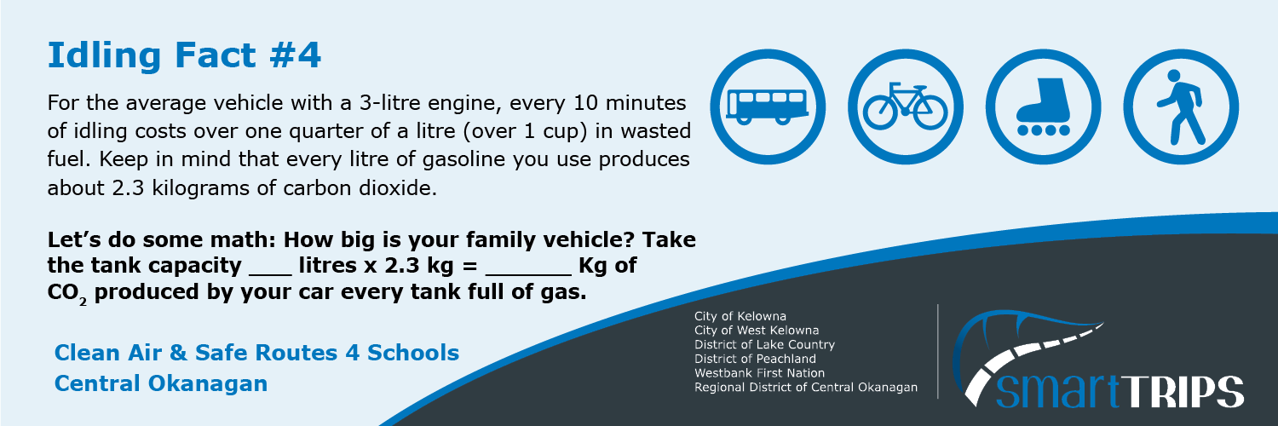

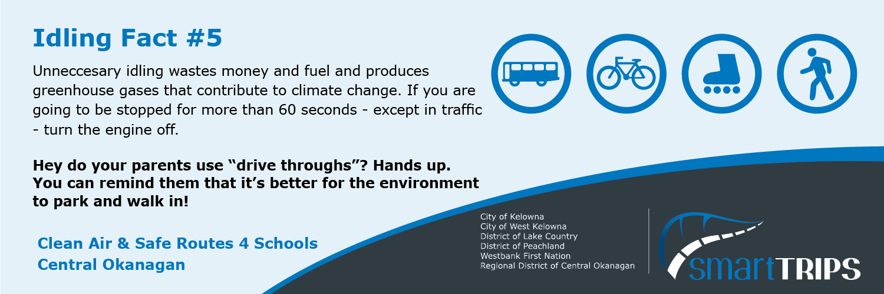

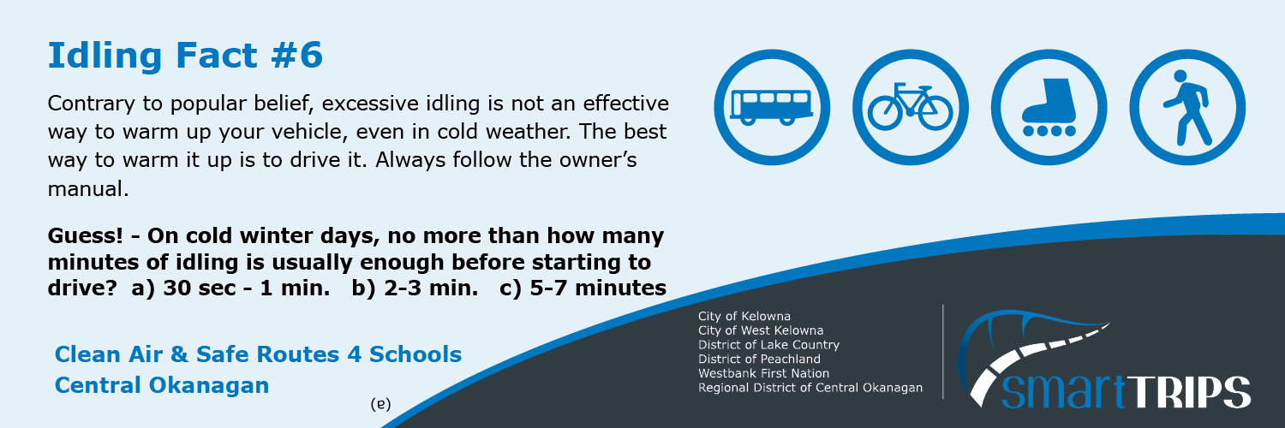

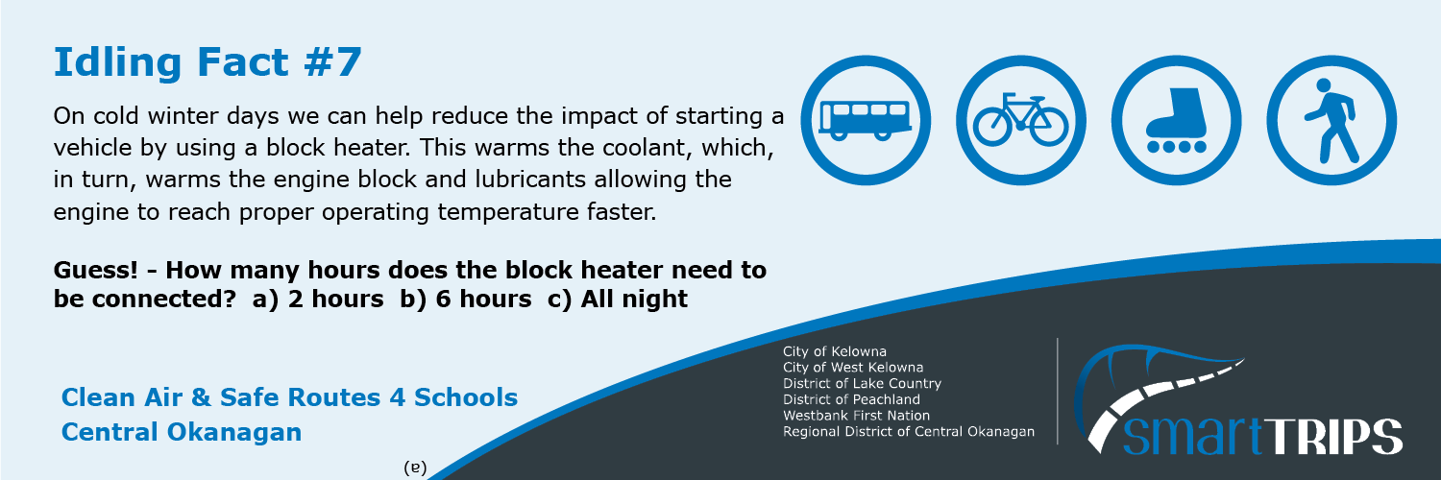
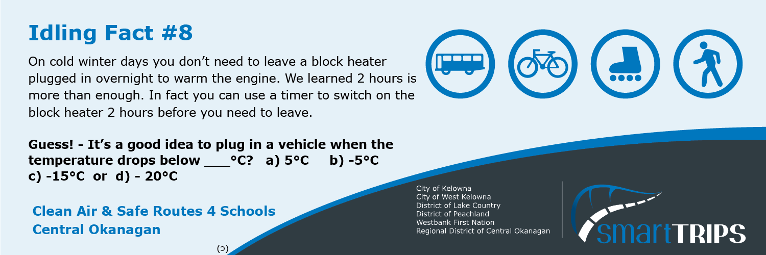
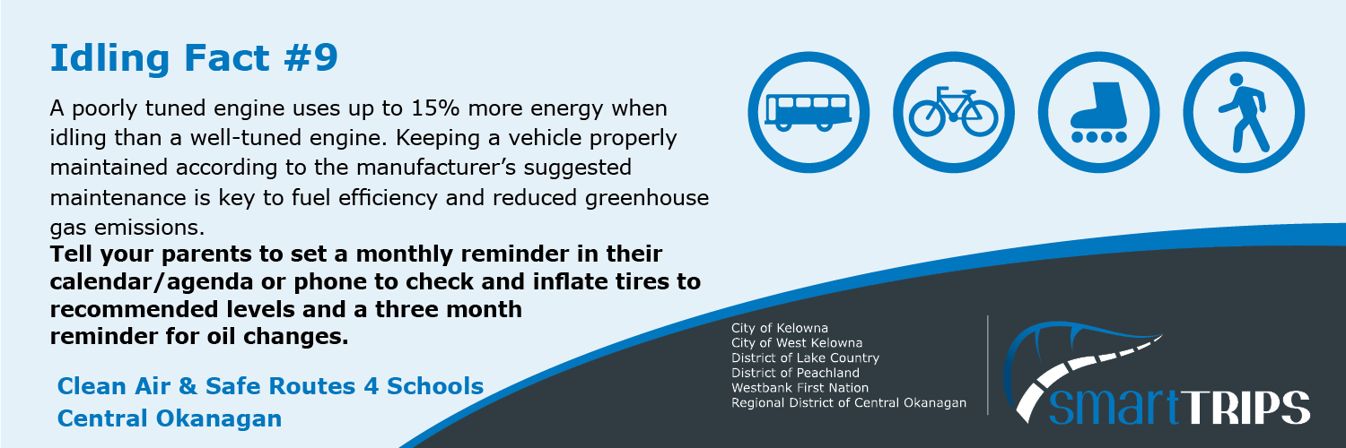
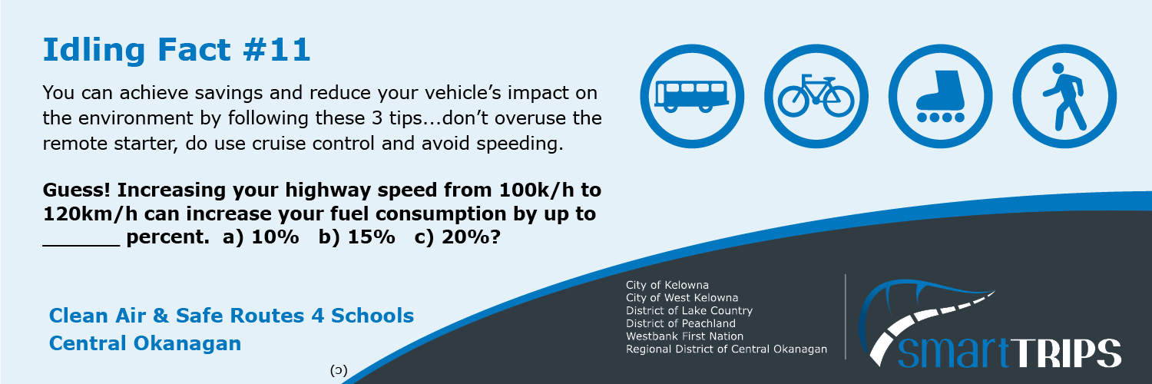
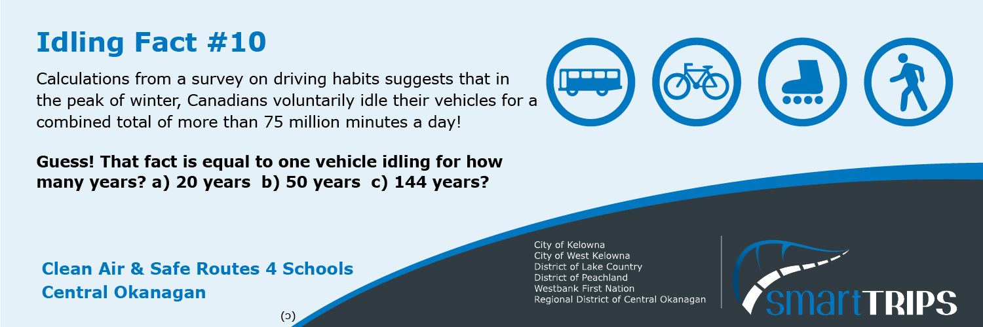
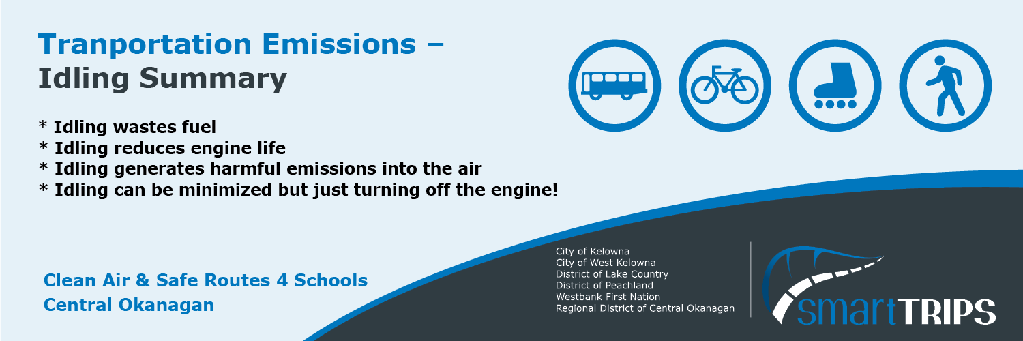

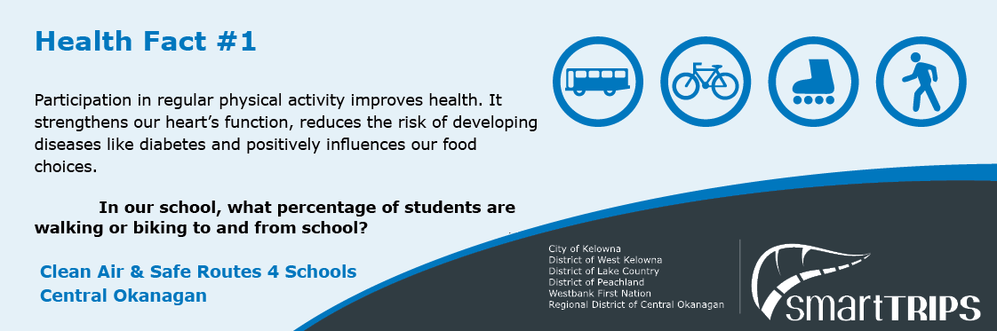
You can find the percentage of students walking and biking in your School Plan Travel: Student Classroom Survey findings” Safe routes 4 schools - Regional District of Central Okanagan (rdco.com)
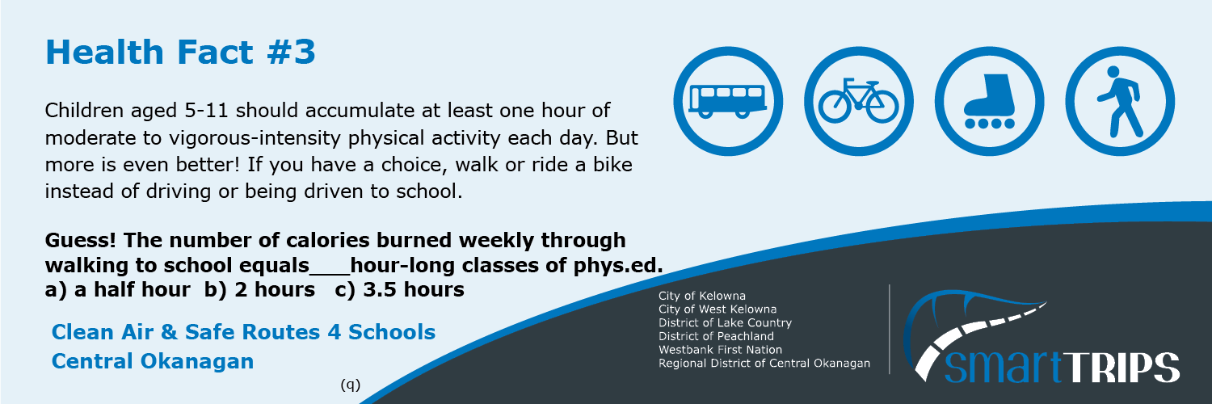
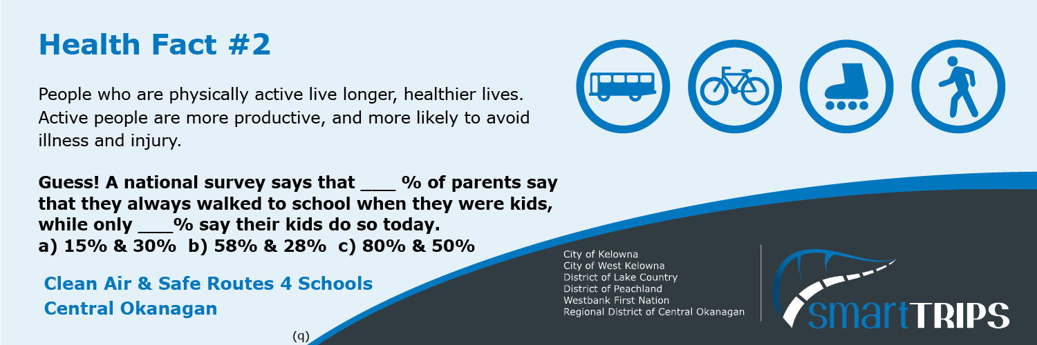

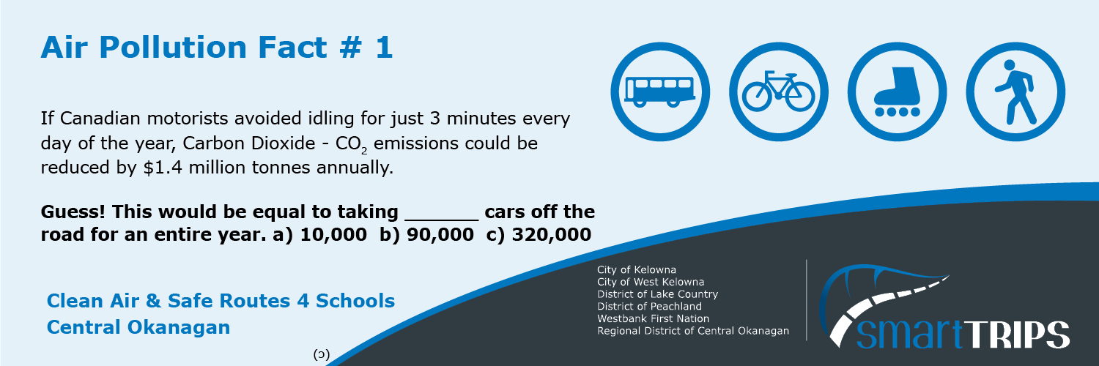
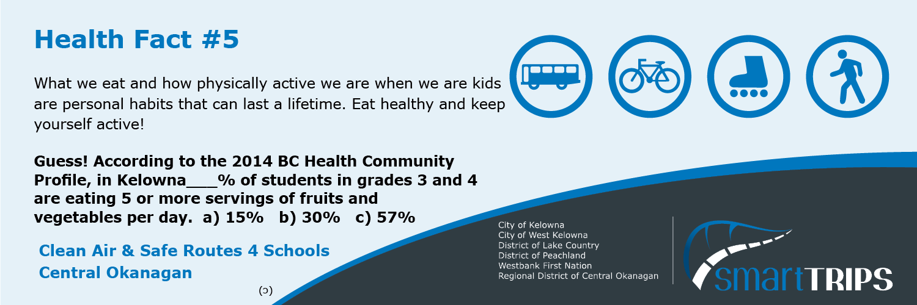
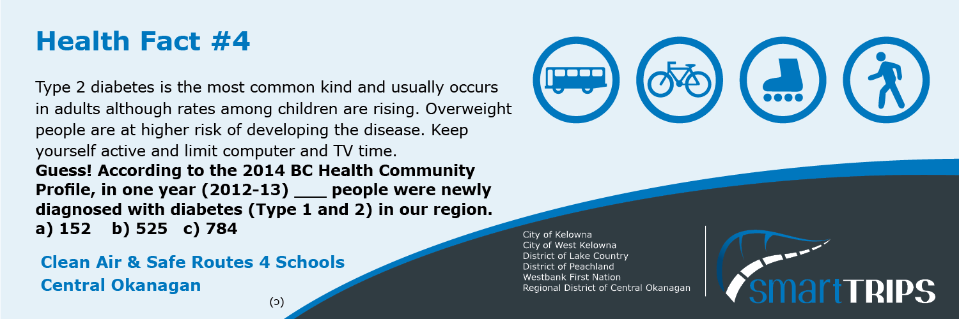

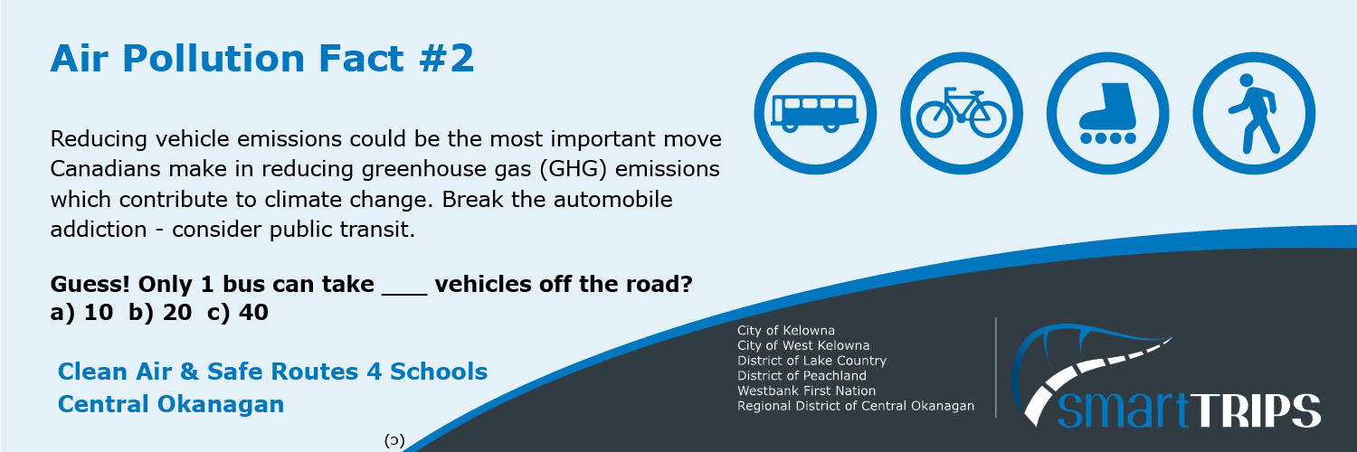

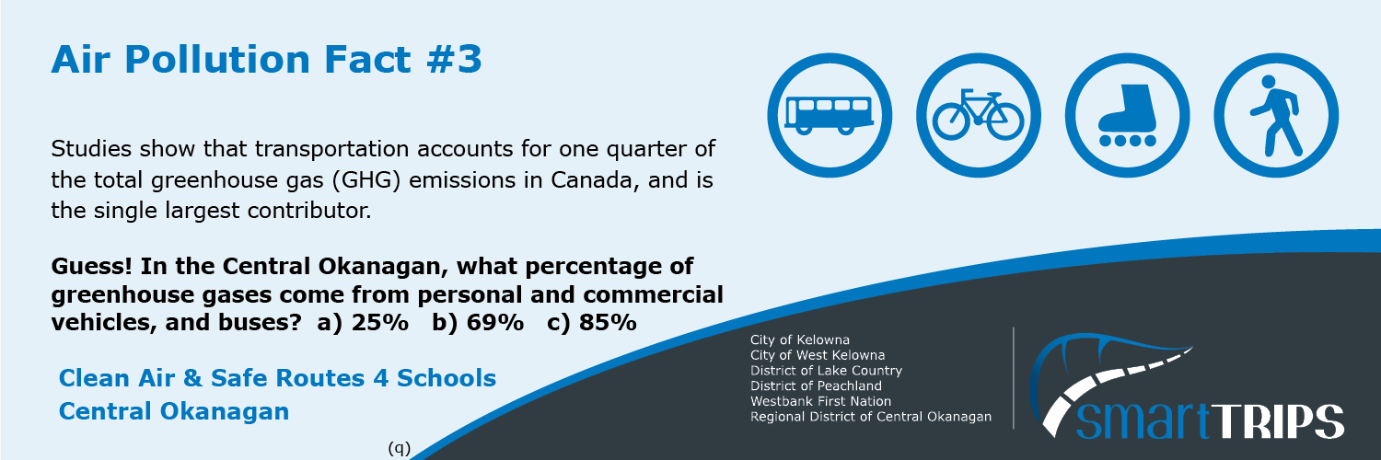
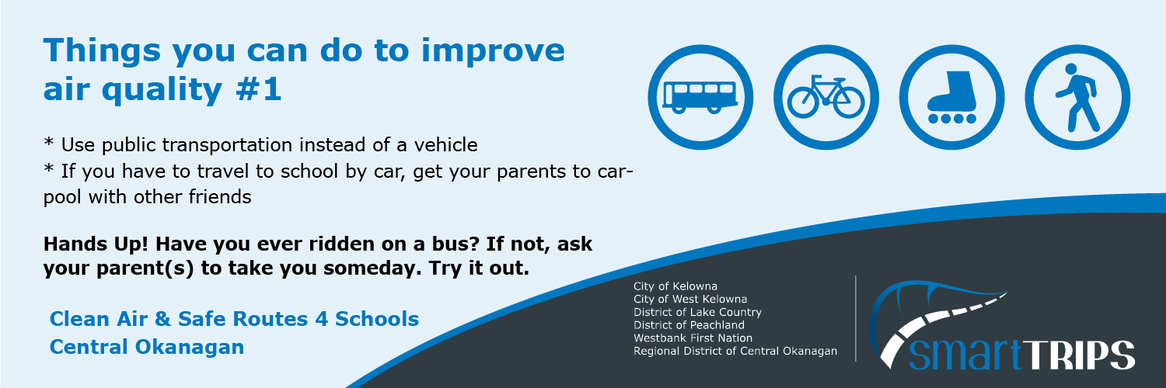

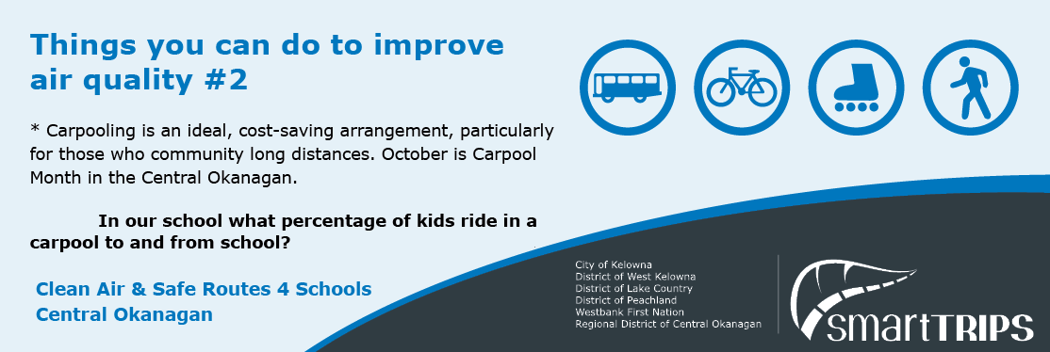

You can find the percentage of kids that carpool in your School Plan Travel: Student Classroom Survey findings” Safe routes 4 schools - Regional District of Central Okanagan (rdco.com)
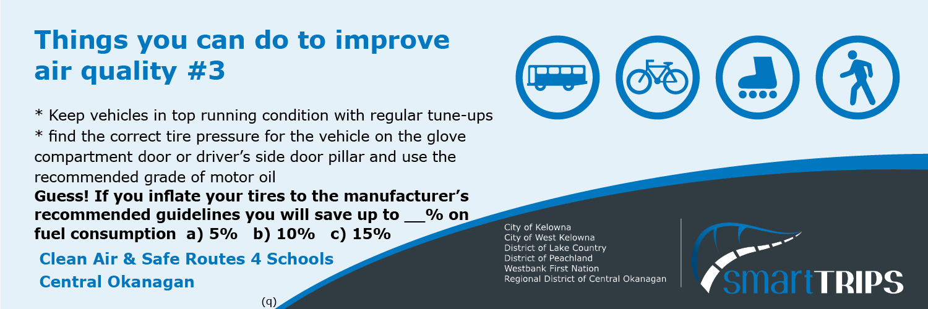
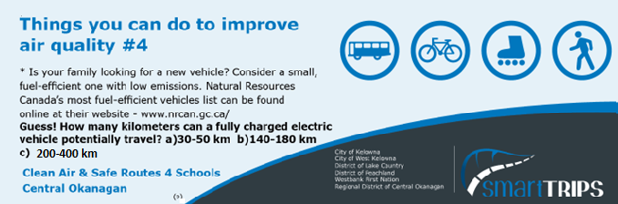

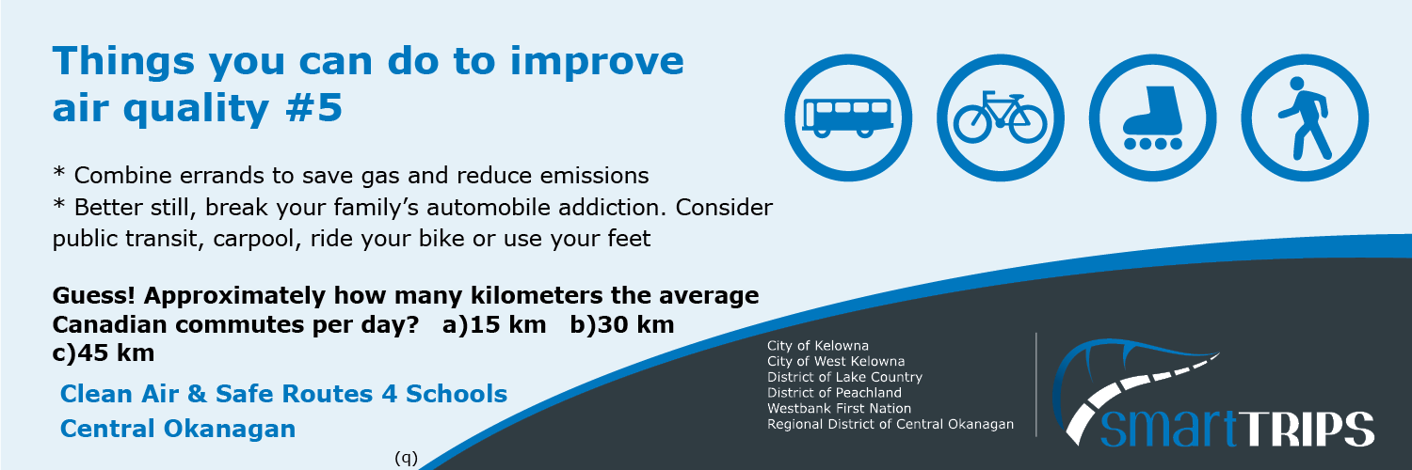
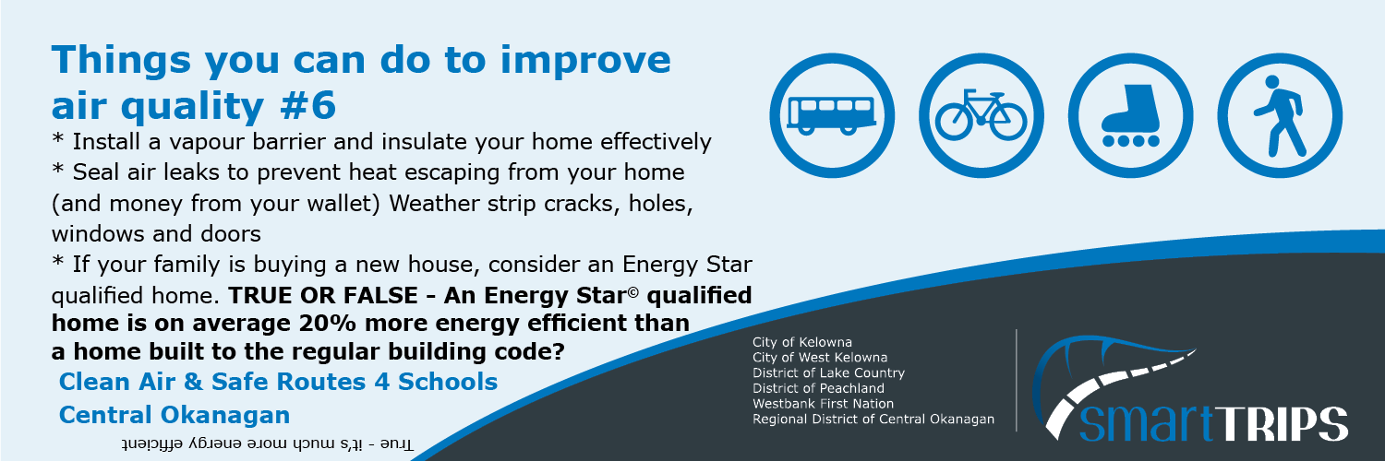
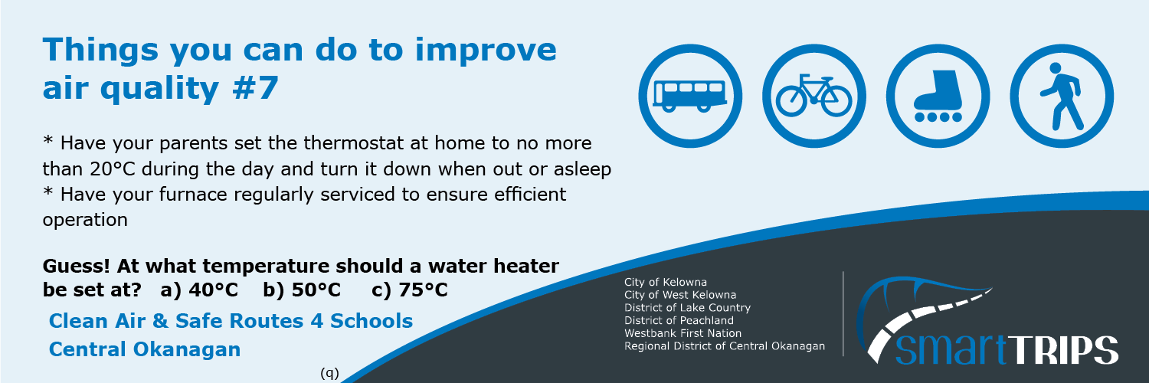
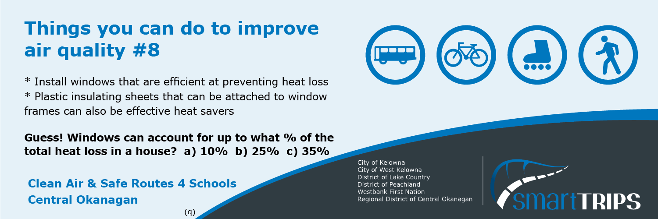

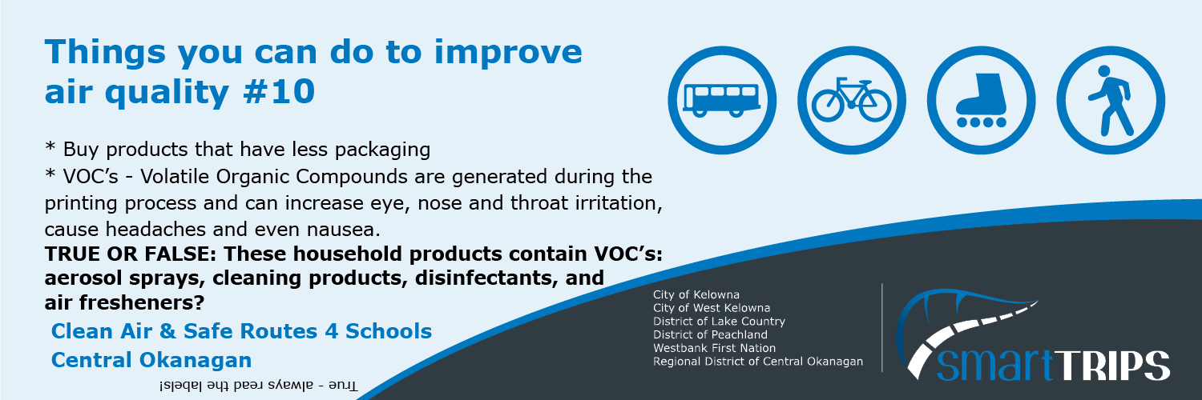
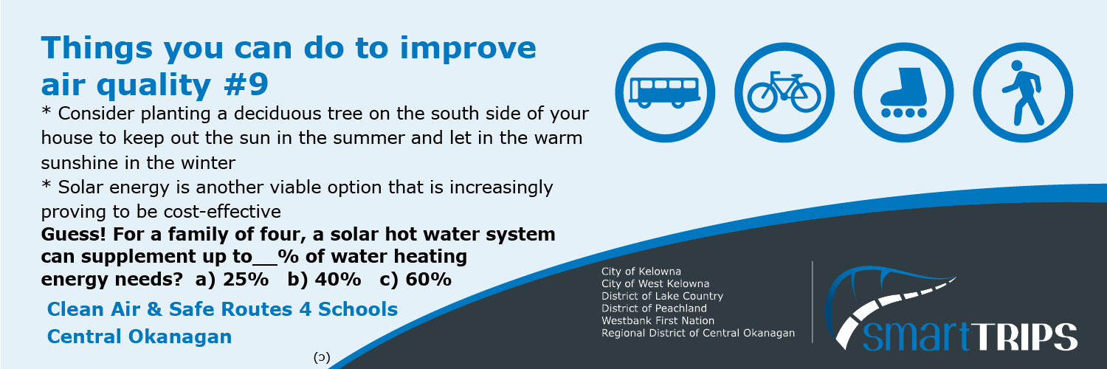
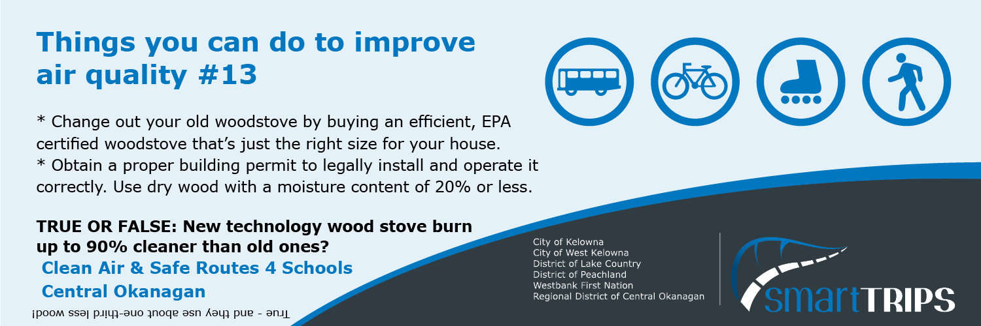
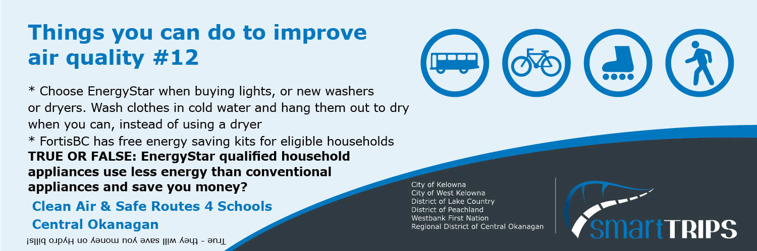
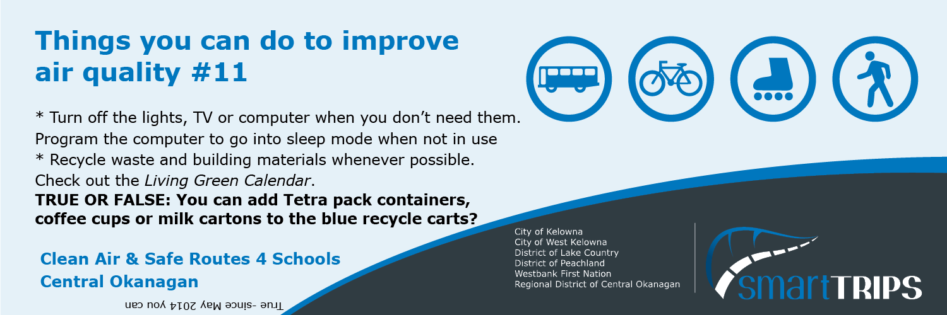

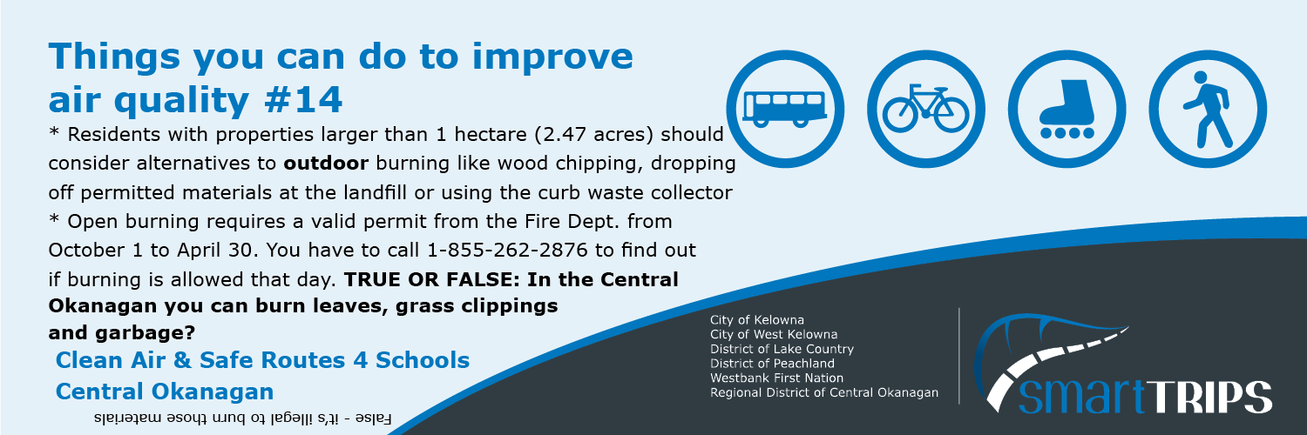

Air Pollution Facts
2023
Questions or concerns should be directed to:
Regional Air Quality Program
rdco.com/airquality
airquality@kelowna.ca
ph. 250-469-8408

This publication is intended for guidance only and may be impacted by changes in legislation, bylaws, policies, and procedures adopted after the date of publication. The use of this publication does not constitute the rendering of legal advice.

